**Multi Region Solutions**

* Consider the following  
  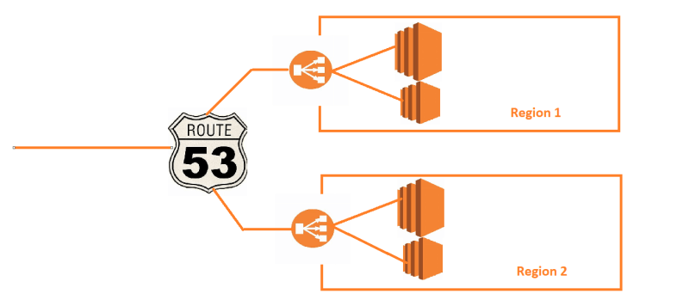
* For Active-Passive, Create a DNS record in Route 53 hosted zone with failover routing
* For Performance , Create a DNS Record in Route 53 hosted zone with latency routing  
  